**IST 263 Exam 1 Review**

**Week 1**

* *Who are the major people involved in the invention of Internet, web, and email?*
  + Internet:
    - 1962: Licklider of MIT
      * Proposed the idea of a network of computer that could talk to each other
  + Email:
    - 1971 Ray Tomlinson develops email
      * Came up with the @ symbol to tell difference between person and location in an email address
  + Web
    - 1991 Tim Berners-Lee (working at CERN) introduced the World Wide Web
      * Helped solve the difficulties scientists were having sharing information
      * Created HTML
      * Created URLs
      * Developed HTTP protocol
      * Director of the World Wide Web Consortium (W3C), which oversees the continued developed of the Web
    - 1971 Vincent Cerf unifies lots of mini networks like ARPANet
      * Developed transmission protocol to help computers talk to each other
* *What is an HTTP request?*
  + Http is the protocol
  + Connects to a server
* *How does a page get routed to a user?*
  + Client types in address
  + http and get request gets connected to a server
  + the server responds to the client  
      
    Diagram

    Description automatically generated
* *Explain what a DNS server does*
  + Translates domain to IP
    - Using HTTP or get post
* *What is an IP address used for?*
  + Helps computers talk to each other
* *What is a protocol? Why are there different protocols and what is the difference?*
  + Protocol determines how data is transmitted between different devices in the same network
  + Different ones have different functions, such as email
* *What’s the difference between a top level domain and a sub-domain?*
  + Top-level domain: .com, .net, .edu, .co
  + Sub-domain: http://its.syr.edu
* *Explain the difference between the Internet and the web*
  + Internet:
    - connected computers that the web works on
    - global network of networks
  + Web
    - A web page is a page of text
    - Used by protocol HTTP
    - Sharing information
* *What web languages are we learning in this class?*
  + HTML, CSS, and JavaScript
* *What is the significance of W3c and what purpose does it serve?*
  + World Wide Web Consortium
  + Created HTML, URLS, HTTP protocol
  + Oversees the continued development of the web
* *What is the syntax to show that a tag is a closing tag?* 
  + </ >

**Week 2**

* *What must be declared in the first line of all HTML documents?*
  + <!DOCTYPE html>
* *What is metadata? Give an example of a tag that uses metadata.*
  + A set of data that describes and gives info about other data
  + <meta charset=”utf-“>
* *What is the difference between a HEAD and BODY tag?*
  + HEAD
    - Contains initial info
    - Where you put meta charset and the title
    - Contains info about web page but not the copy
  + BODY
    - Contains all of the paragraphs, images, etc.
    - What you want shown on the page
* *What is the difference between a tag and an element?*
  + Tag
    - Starts with < and ends with >
    - Whatever is written within a HTML tag are HTML elements
* *What is the purpose of DOCTYPE?*
  + To tell the computer what code language you are using
* *List one of the recommended use case of the H1 tag?*
  + If you want it to be the largest header
* *Give an example of a nested tag.*
  + <ol>  
    <li><strong>food</strong></li>  
    <li>water</li>  
    </ol>
* *What is the difference between block and inline?*
  + Block
    - Always starts on a new line
    - Takes up full width available
    - Has top and bottom margin, whereas inline does not
  + Inline
    - Does not start on a new line
    - Only takes up as much width as necessary
* *What is a void tag? What are some examples of void tags?*
  + HTML tags that are self-closing
  + <br> tag for example
* *What is a character escape?*
  + An HTML character escape is a piece of text ("string") that begins with an ampersand ( & ) and ends with a semicolon ( ; ) . Entities are frequently used to display reserved characters
  + &infin;
* *What are the different types of lists and how can you tell the difference by looking at the code?*
  + Unordered
    - <u1> <!-- u1 means unorder list -->

<li>Item 1</li>

<li>Item 2</li>

</u1>

* + Ordered
    - <ol> <!-- o1 means order list -->

<li>Item 1</li>

<li>Item 2</li>

</ol>

* + Definition

**Week 3**

* *What is fair use?*
  + Permits a party to use copyrighted work without the copyright owner’s permission for purposes such as criticism, comment, news reporting, teaching, scholarship, or research
* *What are some examples of text that cannot be copywritten?*
  + Names
  + Titles
  + Short phrases and expressions
* *What is transformation? What is an example of changing intellectual property that doesn't satisfy the transformation definition?*
  + Type of fair use that builds on copyrighted work in a different manner for a different purpose from the original
    - Does not infringe its holder’s copyright
* *What is an HTML attribute and what is an example of an attribute?*
  + All HTML elements can have attributes
  + Attributes are always specified in the start of the tag
  + Attributes provide additional information about elements
  + Attributes usually come in name/value pairs: name=”value”
* *What is the difference between a relative link and an external link?*
  + External link
    - Full URL including http
      * <a href="http://www.google.com">Google</a>
  + Relative link
    - Refer to page based on the current page’s relative location
      * <a href="about.htm">Page in Same Folder</a>
* *Why is the 'alt' attribute important in an image tag?*
  + Alt attribute described image as text
  + <img src="images/photo.jpg" alt="my photo">
* *What is the attribute href used for?*
  + An attribute of the anchor tag, which is also used to identify sections within a document
  + Specifies the URL of the page the link goes to
  + If it is not present, it will not be a hyperlink
* *What does the notations ../ do? Give an example of how it should be used.*
  + Determine the folder your file resides in.
  + Traveling only along the lines figure out the path you want to travel to get to the folder that contains the file you want to link to.
    - Every time you go up to a parent folder you add a ../
    - Every time you go down to a sub folder you add a /folder_name where folder_name is the actual name of your folder
  + Once you have arrived at the correct folder, add a /file_name to the end of your path where file_name is the actual name of your file.
  + **../ goes up and to the left
* *What does the src attribute do? What element is it associated with?*
  + Src attribute specifies image location
  + Associated with <img element
* *What does the iframe tag do?*
  + An inline frame used to embed another document within the current HTML document
  + Title attribute describes the content of the iframe and should always be used
  + Used to insert content from another source

**Week 4**

* *What are tables used for?*
  + Allow web developers to arrange data into rows and columns
* *What is the difference between the td and th tags?*
  + Td
    - One cell in a table
  + Th
    - One header in a table
  + Example of code: *A picture containing text

    Description automatically generated*
* *What does the method attribute do? What does the action attribute do?*
  + Method attribute
    - Used to specify the HTTP method used to send data while submitting the form
    - The way data is sent
  + Action attribute
    - What should happen to data when a form is submitted on a web page
* *What is the difference between get and post?*
  + Get
    - Sends the form data across the URL
  + Post
    - Sends the form data on a special header with the http request
* *Why do we need the label element? What does the for attribute do inside the label element?*
  + Label elements create caption for a form control and improves usability
* *What form element would you use to allow someone to type paragraphs of text?*
  + <p>
  + <textarea
    - For lots of writing in a form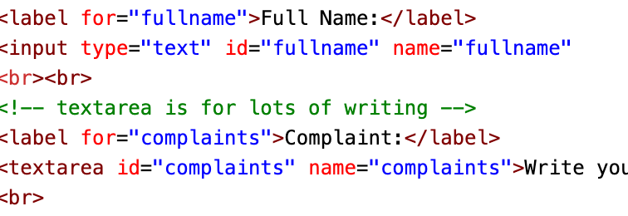
* *What form element would you use if you wanted to force someone to type one of three options? Is there another form element that works just as well?*
  + Radio button:
    - 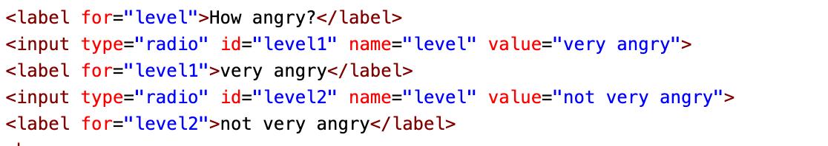
  + Checkbox:
    - **
  + Dropdown list
    - 